Let’s begin by importing our data set into SQLite, luckily we can add the first row as the column names but if we couldn’t we would use the following code:

ALTER TABLE games

RENAME COLUMN field1 TO id;

RENAME COLUMN field2 TO title;

RENAME COLUMN field3 TO release_date;

RENAME COLUMN field4 TO production_team;

RENAME COLUMN field5 TO rating;

RENAME COLUMN field6 TO times_listed;

RENAME COLUMN field7 TO number_of_reviews;

RENAME COLUMN field8 TO genres;

RENAME COLUMN field9 TO summary;

RENAME COLUMN field10 TO reviews;

RENAME COLUMN field11 TO plays;

RENAME COLUMN field12 TO playing;

RENAME COLUMN field13 TO backlogs;

RENAME COLUMN field14 TO wishlist;

SELECT * FROM games;

Now that our data set is imported with the proper column names, let’s begin to wrangle some of our data.

—Add year column to help group games by release date

ALTER TABLE games

ADD column year integer;

—Insert values into the new column

UPDATE games SET year = SUBSTR(releasedate, 9, 4);

—Commit the TRANSACTION

COMMIT;

—Let's look at the new TABLE and categorize our data set into two segments: retro games and newer games. Retro games will be classified as all games released before the year 2000.

SELECT year,

CASE

WHEN year > 2000 THEN 'new'

ELSE 'retro'

END AS game_type

FROM games

LIMIT 10;

|  |  |
| --- | --- |
| 2022 | new |
| 2019 | new |
| 2017 | new |
| 2015 | new |
| 2017 | new |
| 2011 | new |
| 2020 | new |
| 2021 | new |
| 2018 | new |
| 2017 | new |

ALTER TABLE games

ADD column game_type text;

UPDATE games

SET game_type = CASE

WHEN year > 2000 THEN 'new'

ELSE 'retro'

END;

COMMIT;

Let’s take a look at our improved table with the following columns: title, year, game_type, rating, plays:

SELECT title, year, game_type, rating, plays

FROM games

LIMIT 10;

|  |  |  |  |  |
| --- | --- | --- | --- | --- |
| Elden Ring | 2022 | new | 4.5 | 17K |
| Hades | 2019 | new | 4.3 | 21K |
| The Legend of Zelda: Breath of the Wild | 2017 | new | 4.4 | 30K |
| Undertale | 2015 | new | 4.2 | 28K |
| Hollow Knight | 2017 | new | 4.4 | 21K |
| Minecraft | 2011 | new | 4.3 | 33K |
| Omori | 2020 | new | 4.2 | 7.2K |
| Metroid Dread | 2021 | new | 4.3 | 9.2K |
| Among Us | 2018 | new | 3.0 | 25K |
| NieR: Automata | 2017 | new | 4.3 | 18K |

I wonder what the top 10 best-selling new games are? Let’s see. Let’s order our data by rating and extract only the titles released AFTER 2000.

SELECT title, year, game_type, rating, plays

FROM games

WHERE game_type = 'retro'

ORDER BY Rating

LIMIT 10;

|  |  |  |  |  |
| --- | --- | --- | --- | --- |
| Final Fantasy XVI | 2023 | new |  | 37 |
| Death Stranding 2 | on | new |  | 3 |
| Final Fantasy VII Rebirth | 2023 | new |  | 20 |
| Lies of P | 2023 | new |  | 5 |
| Judas | 2025 | new |  | 1 |
| Like a Dragon Gaiden: The Man Who Erased His Name | 2023 | new |  | 2 |
| The Legend of Zelda: Tears of the Kingdom | 2023 | new |  | 72 |
| Star Wars Jedi: Survivor | 2023 | new |  | 13 |
| We Love Katamari Reroll + Royal Reverie | 2023 | new |  | 3 |
| Earthblade | 2024 | new |  | 0 |

This data looks off, the NULL values are still in, this data set wasn’t properly cleaned before, let’s do some cleaning now by removing all the rows with NULL values and check for duplicates.

Let’s check for duplicates first to ensure our data is as accurate as possible.

SELECT title, COUNT(*) AS 'count'

FROM games

GROUP BY title

HAVING count > 1;

WOW! 279 duplicate cases, let’s get rid of those.

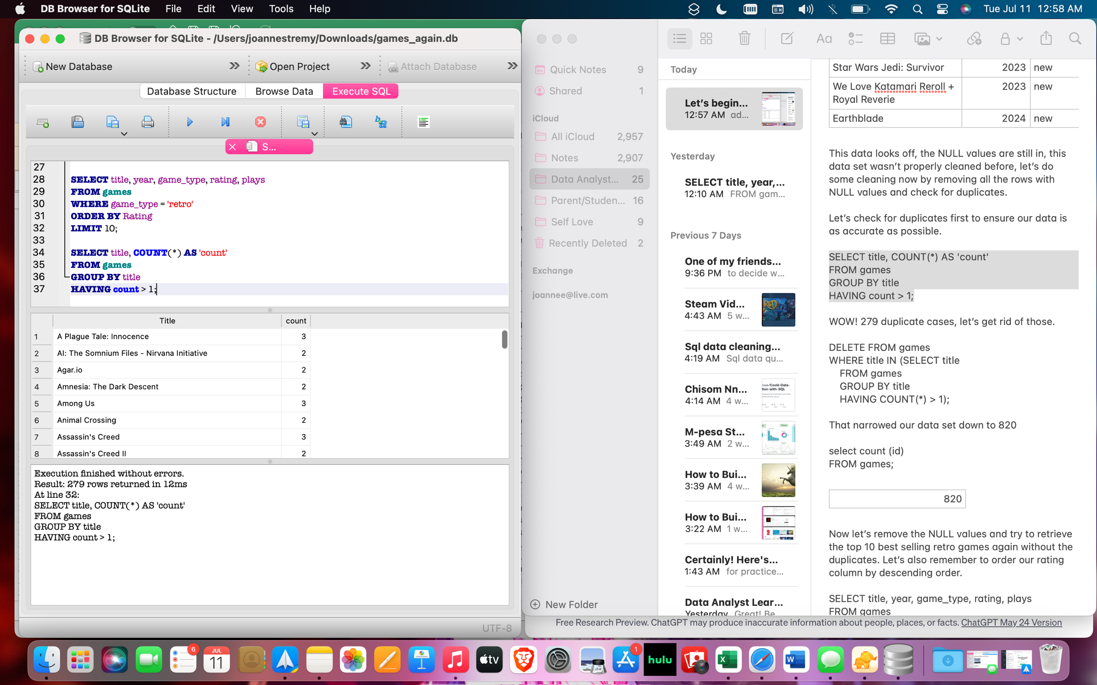

DELETE FROM games

WHERE title IN (SELECT title

FROM games

GROUP BY title

HAVING COUNT(*) > 1);

That narrowed our data set down to 820

select count (id)

FROM games;

|  |
| --- |
| 820 |

Now let’s remove the NULL values and try to retrieve the top 10 best selling retro games again without the duplicates. Let’s also remember to order our rating column by descending order.

SELECT title, year, game_type, rating, plays

FROM games

WHERE game_type = 'retro' AND rating IS NOT NULL

ORDER BY Rating DESC

LIMIT 10;

|  |  |  |  |  |
| --- | --- | --- | --- | --- |
| Castlevania: Symphony of the Night | 1997 | retro | 4.4 | 9.1K |
| The Legend of Zelda: Majora's Mask | 2000 | retro | 4.4 | 13K |
| Final Fantasy VI | 1994 | retro | 4.4 | 6.1K |
| Moon: Remix RPG Adventure | 1997 | retro | 4.4 | 663 |
| Suikoden II | 1998 | retro | 4.4 | 1.1K |
| Super Metroid | 1994 | retro | 4.3 | 11K |
| Final Fantasy IX | 2000 | retro | 4.3 | 6.8K |
| Planescape: Torment | 1999 | retro | 4.3 | 1.1K |
| Super Mario World | 1990 | retro | 4.2 | 18K |
| EarthBound | 1994 | retro | 4.2 | 9K |

I think my friend might have some of these already, let’s try looking at the top 100 so he has more variety. Let’s give him a list of the top 100 retro games and then a separate list with the top 100 new games.

SELECT title, year, game_type, rating, plays

FROM games

WHERE game_type = 'new' AND rating IS NOT NULL

ORDER BY Rating DESC

LIMIT 100;

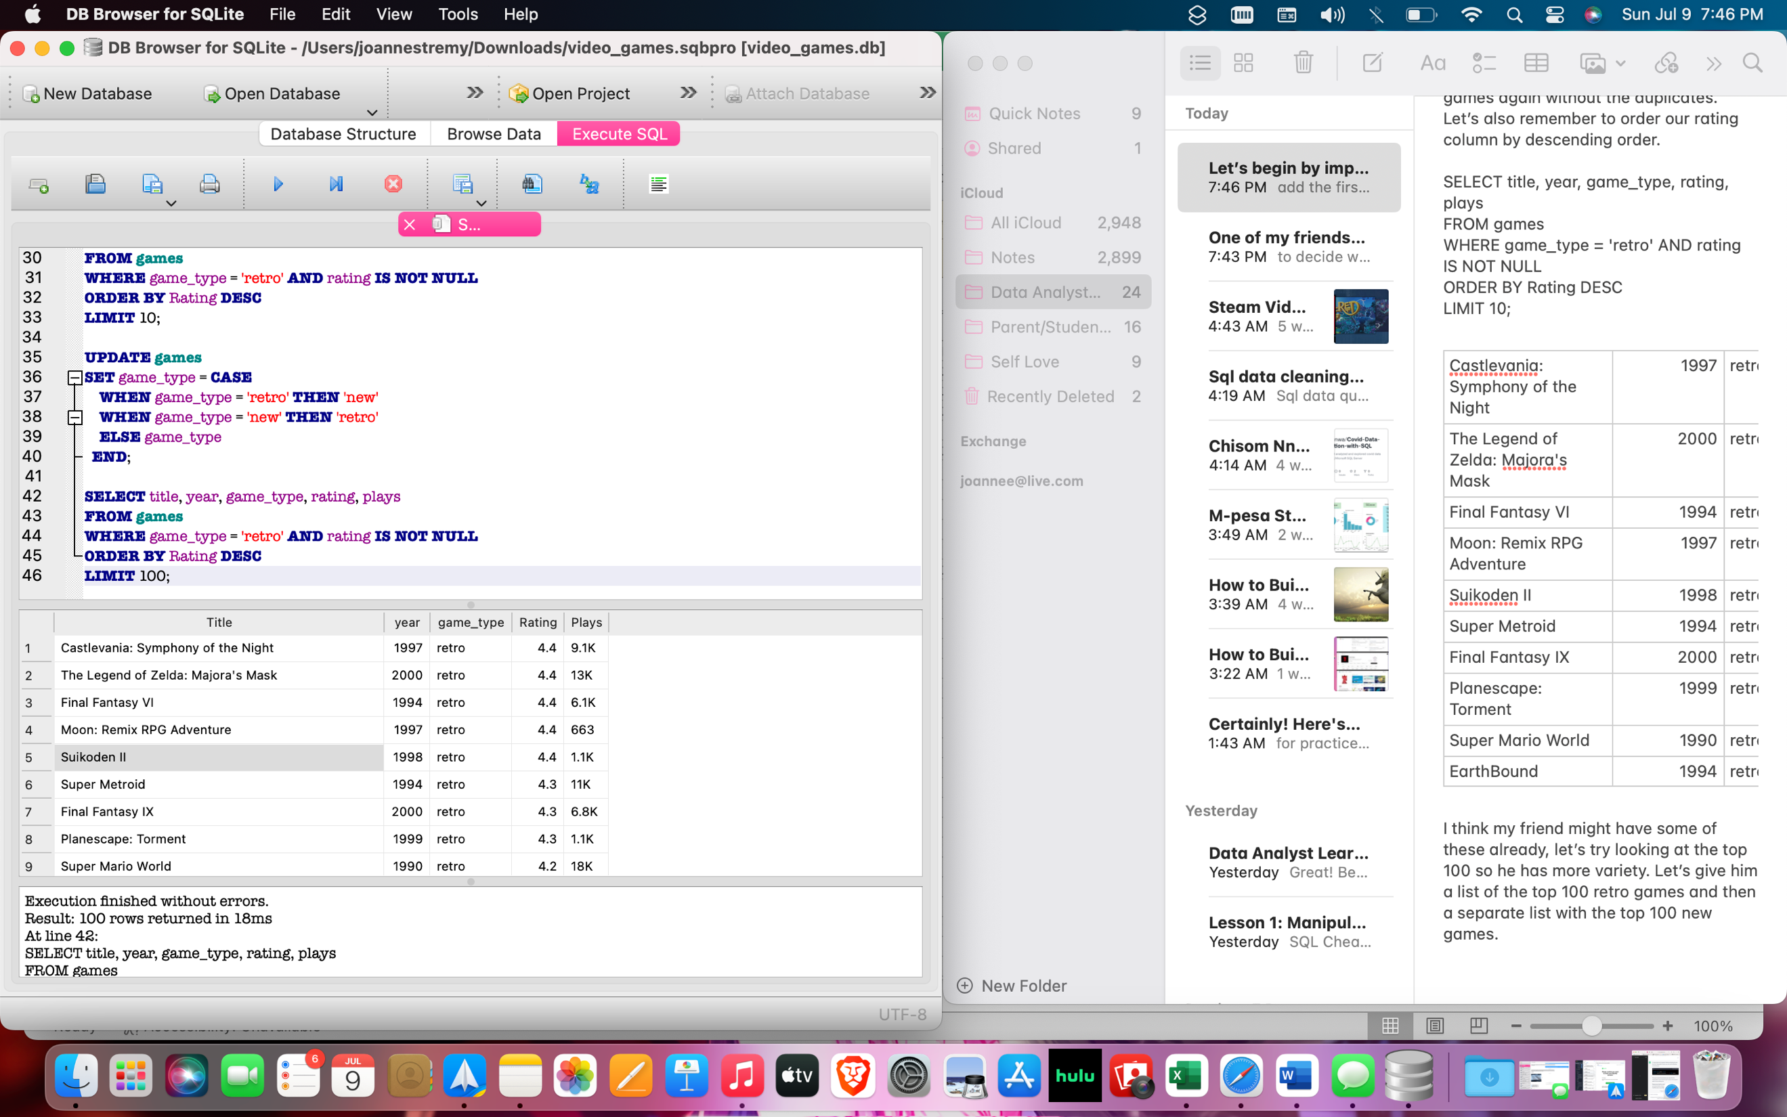

(Table condensed to 10 to shorten document)

|  |  |  |  |  |
| --- | --- | --- | --- | --- |
| Castlevania: Symphony of the Night | 1997 | retro | 4.4 | 9.1K |
| The Legend of Zelda: Majora's Mask | 2000 | retro | 4.4 | 13K |
| Final Fantasy VI | 1994 | retro | 4.4 | 6.1K |
| Moon: Remix RPG Adventure | 1997 | retro | 4.4 | 663 |
| Suikoden II | 1998 | retro | 4.4 | 1.1K |
| Super Metroid | 1994 | retro | 4.3 | 11K |
| Final Fantasy IX | 2000 | retro | 4.3 | 6.8K |
| Planescape: Torment | 1999 | retro | 4.3 | 1.1K |
| Super Mario World | 1990 | retro | 4.2 | 18K |
| EarthBound | 1994 | retro | 4.2 | 9K |

This is exactly what we wanted, let’s look at new games next.

SELECT title, year, game_type, rating, plays

FROM games

WHERE game_type = 'new' AND rating IS NOT NULL

ORDER BY Rating DESC

LIMIT 100;

|  |  |  |  |  |
| --- | --- | --- | --- | --- |
| Elden Ring: Shadow of the Erdtree | on | new | 4.8 | 1 |
| Hitman World of Assassination | 2023 | new | 4.6 | 167 |
| Final Fantasy XIV: Endwalker | 2021 | new | 4.6 | 2.5K |
| Metal Gear Solid 3: Subsistence | 2005 | new | 4.6 | 3.7K |
| Final Fantasy XIV: Shadowbringers | 2019 | new | 4.6 | 3K |
| The Great Ace Attorney 2: Resolve | 2017 | new | 4.6 | 1.1K |
| Sekiro: Shadows Die Twice - GOTY Edition | 2020 | new | 4.6 | 1.4K |
| Half-Life: Alyx | 2020 | new | 4.6 | 1.9K |
| Dwarf Fortress | 2022 | new | 4.6 | 225 |

The first entry on this list has an invalid year because it hasn’t been released yet. Let’s remove rows in our data set without a valid year.

DELETE FROM games

WHERE year NOT LIKE '19%' AND year NOT LIKE '20%';

Let’s run the original query again

SELECT title, year, game_type, rating, plays

FROM games

WHERE game_type = 'new' AND rating IS NOT NULL

ORDER BY Rating DESC

LIMIT 100;

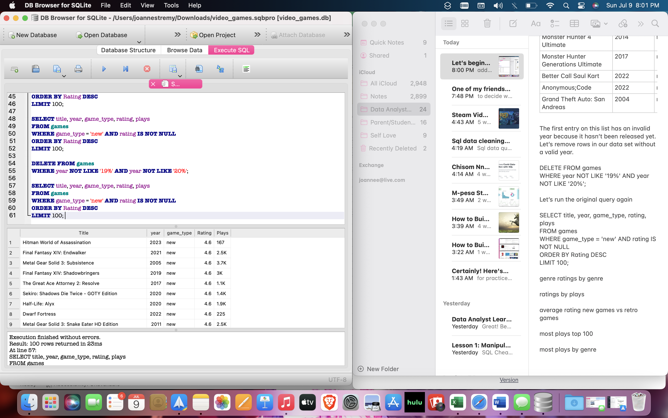

|  |  |  |  |  |
| --- | --- | --- | --- | --- |
| Hitman World of Assassination | 2023 | new | 4.6 | 167 |
| Final Fantasy XIV: Endwalker | 2021 | new | 4.6 | 2.5K |
| Metal Gear Solid 3: Subsistence | 2005 | new | 4.6 | 3.7K |
| Final Fantasy XIV: Shadowbringers | 2019 | new | 4.6 | 3K |
| The Great Ace Attorney 2: Resolve | 2017 | new | 4.6 | 1.1K |
| Sekiro: Shadows Die Twice - GOTY Edition | 2020 | new | 4.6 | 1.4K |
| Half-Life: Alyx | 2020 | new | 4.6 | 1.9K |
| Dwarf Fortress | 2022 | new | 4.6 | 225 |
| Metal Gear Solid 3: Snake Eater HD Edition | 2011 | new | 4.6 | 2.5K |

Now let’s look and see if genre impacts ratings at all. My friend doesn’t need this but it would be nice to see which genre of games are most popular and which ones are highest rated.

Let’s look at all of the distinct genres in our data set first.

SELECT DISTINCT Genres

FROM games;

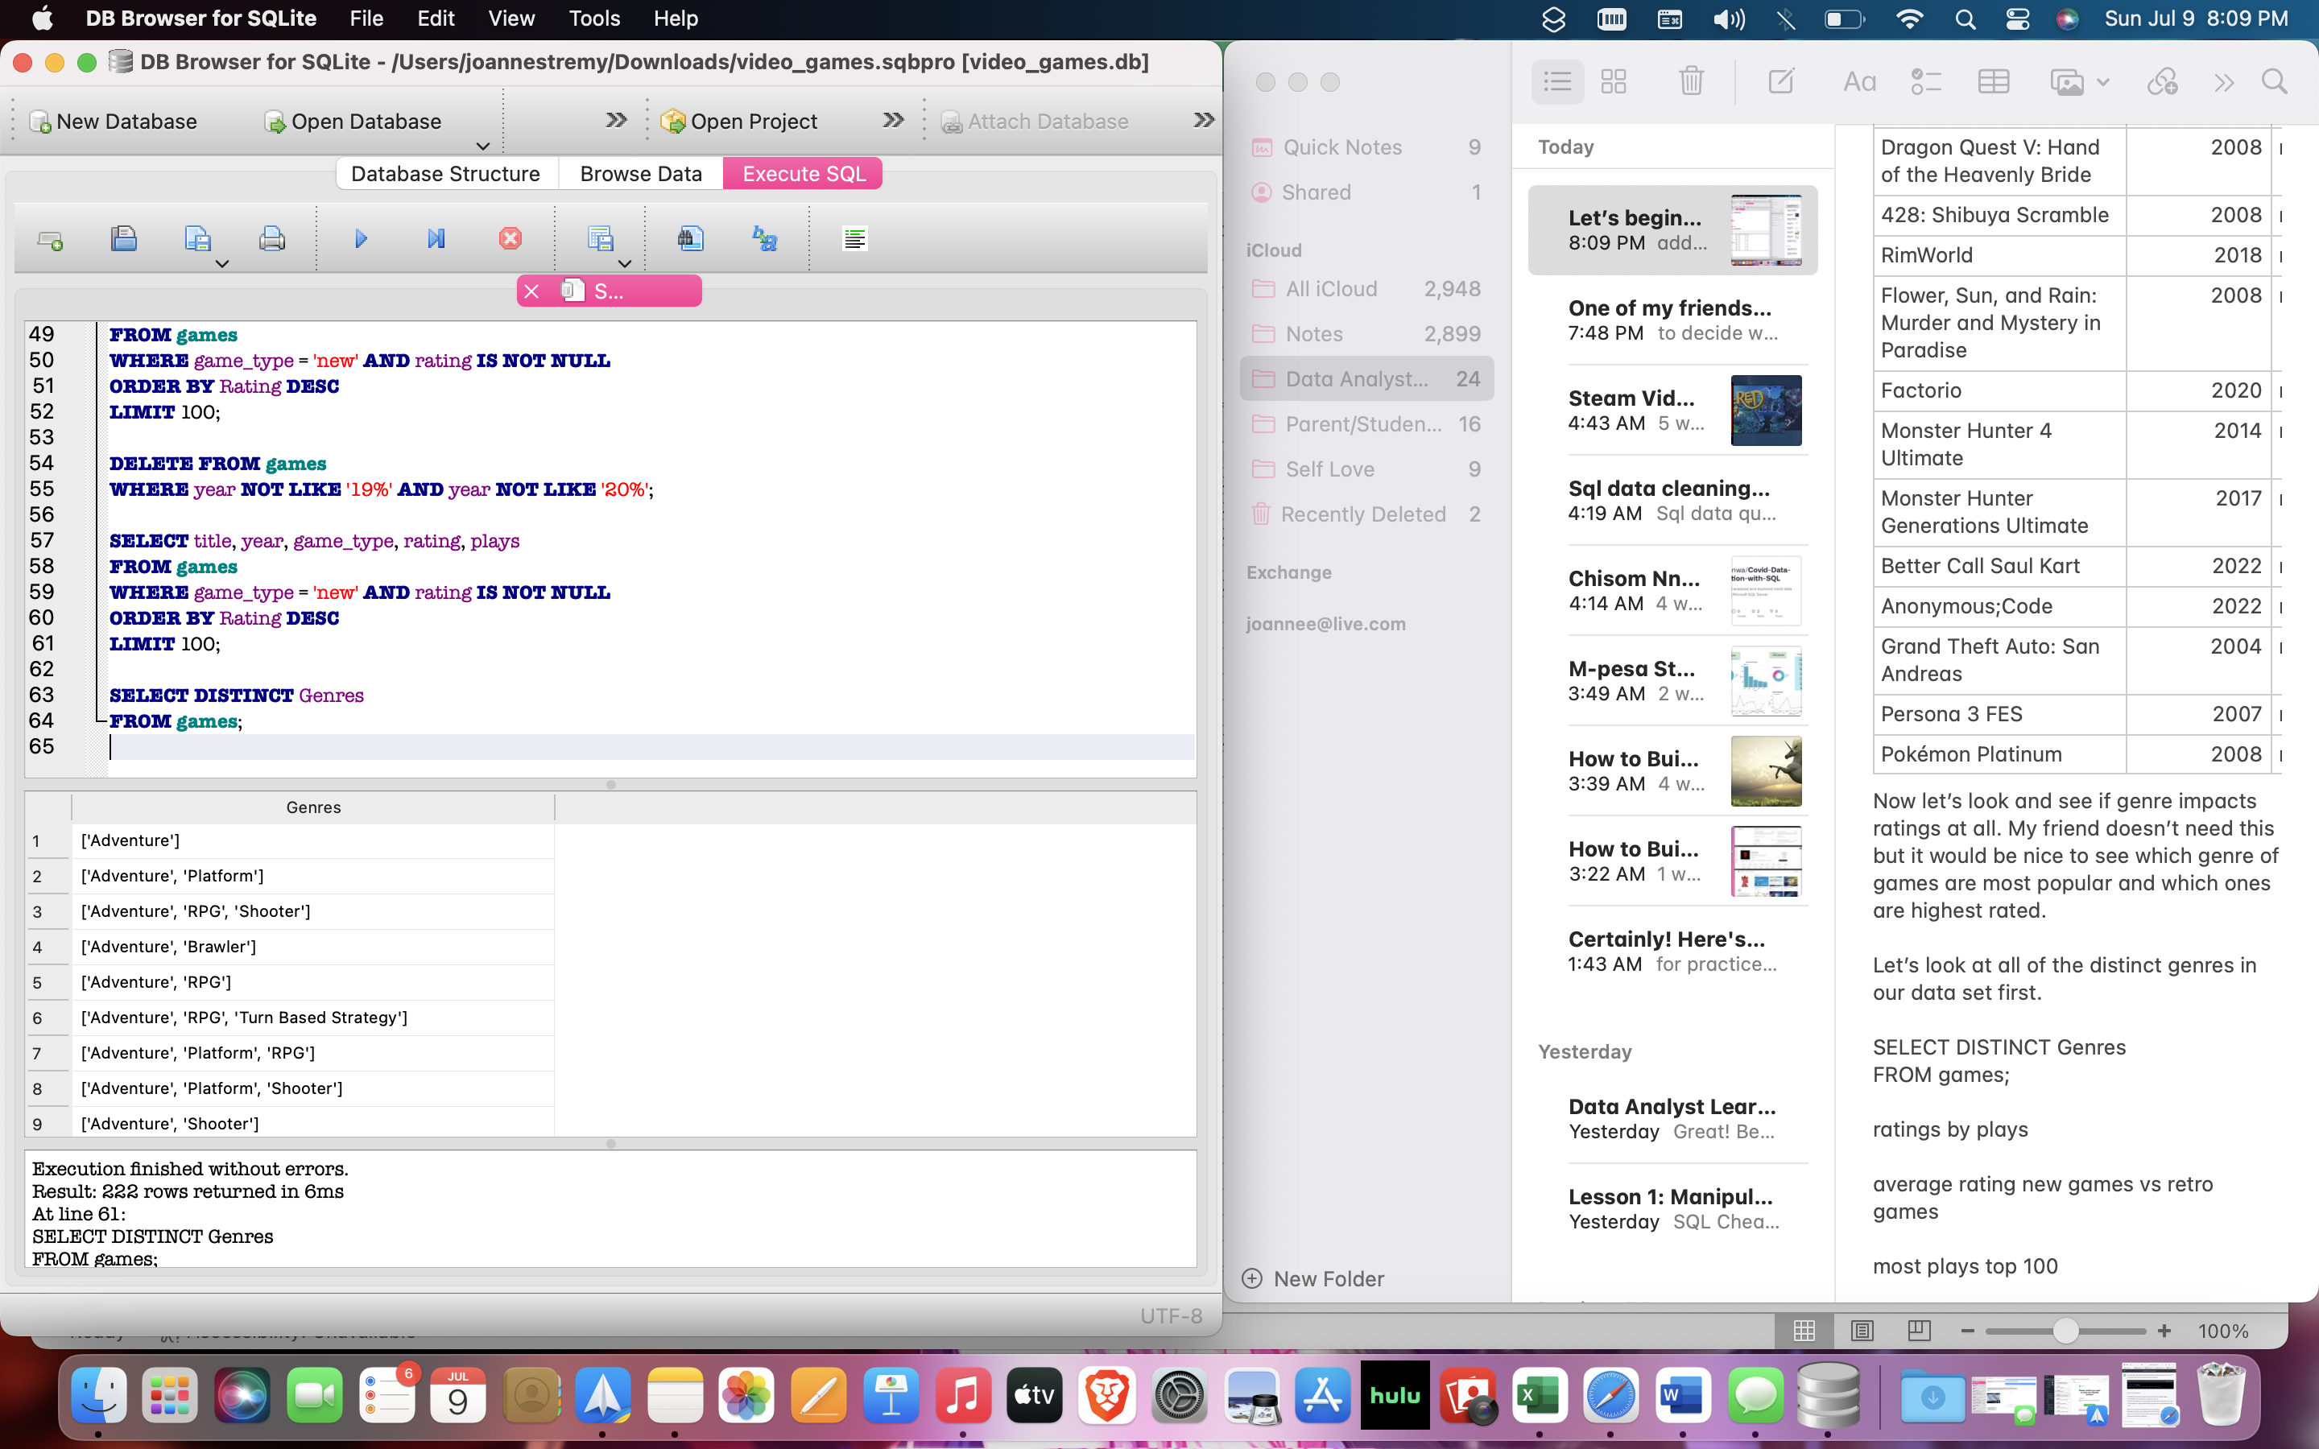

|  |
| --- |
| ['Adventure'] |
| ['Adventure', 'Platform'] |
| ['Adventure', 'RPG', 'Shooter'] |
| ['Adventure', 'Brawler'] |
| ['Adventure', 'RPG'] |
| ['Adventure', 'RPG', 'Turn Based Strategy'] |
| ['Adventure', 'Platform', 'RPG'] |
| ['Adventure', 'Platform', 'Shooter'] |
| ['Adventure', 'Shooter'] |
| ['Adventure', 'Indie', 'Platform', 'RPG', 'Strategy'] |
| ['Adventure', 'Shooter', 'Tactical'] |
| ['Shooter', 'Strategy'] |
| ['Shooter'] |
| ['Adventure', 'RPG', 'Strategy', 'Tactical', 'Turn Based Strategy'] |
| ['Adventure', 'Racing', 'Shooter'] |
| ['Adventure', 'Simulator', 'Strategy', 'Tactical'] |
| ['RPG', 'Simulator', 'Visual Novel'] |
| ['Brawler'] |
| ['Arcade', 'Racing'] |
| ['Arcade', 'Indie', 'Shooter'] |

Hmm because our data set includes every sub-genre of the game title, it might be a little difficult to group, lets clean the genre title a bit by only using the main genre of the game, the first title in our genre list.

SELECT DISTINCT SUBSTR(genres, 1, INSTR(genres, ',') - 1) AS 'genres_new'

FROM games

WHERE genres IS NOT NULL AND genres LIKE '%';

Here are our new distinct genres cleaned up in a new column to maintain the integrity of the previous data file just in case we need to go back and look at something, we’ll edit the table at the end before we save our final data set.

|  |
| --- |
|  |
| 'Shooter' |
| 'RPG' |
| 'Arcade' |
| 'Indie' |
| 'Puzzle' |
| 'Music' |
| 'Brawler' |

Wait, our friend says he doesn’t want to know about the genres and would rather see all of the quantitative data columns only. Let’s drop the text rows from our table.

ALTER TABLE games

DROP COLUMN Genres;

ALTER TABLE games

DROP COLUMN Reviews;

ALTER TABLE games

DROP COLUMN Summary;

ALTER TABLE games

DROP COLUMN Team;

Let’s look at our new table:

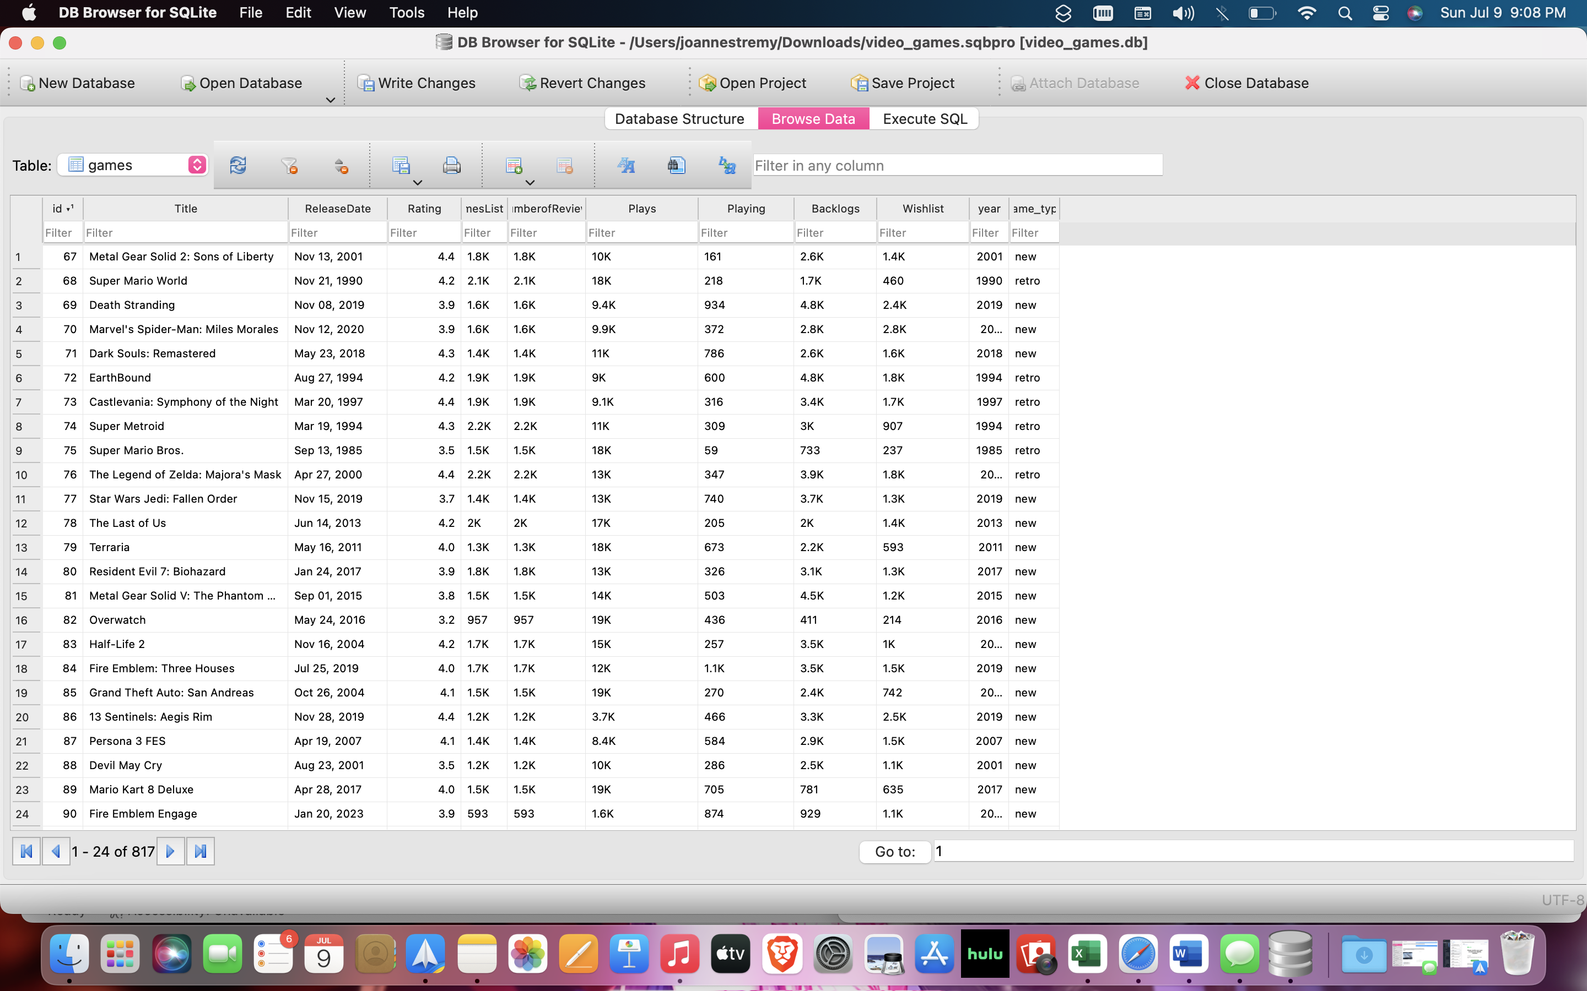

Our friend wasn’t interested in genres, but he might care about whether or not game rating affects how many users play a game, let’s see.

SELECT title, plays, rating

FROM games

WHERE rating IS NOT NULL

ORDER BY rating DESC

LIMIT 50;

|  |  |  |
| --- | --- | --- |
| Hitman World of Assassination | 167 | 4.6 |
| Final Fantasy XIV: Endwalker | 2.5K | 4.6 |
| Metal Gear Solid 3: Subsistence | 3.7K | 4.6 |
| Final Fantasy XIV: Shadowbringers | 3K | 4.6 |
| The Great Ace Attorney 2: Resolve | 1.1K | 4.6 |
| Sekiro: Shadows Die Twice - GOTY Edition | 1.4K | 4.6 |
| Half-Life: Alyx | 1.9K | 4.6 |
| Dwarf Fortress | 225 | 4.6 |
| Metal Gear Solid 3: Snake Eater HD Edition | 2.5K | 4.6 |
| Tokyo Necro | 14 | 4.6 |
| Bloodborne: Game of the Year Edition | 1.5K | 4.6 |
| Pizza Tower | 1.2K | 4.5 |
| Metroid Prime Remastered | 1.1K | 4.5 |
| Mother 3 | 5.7K | 4.5 |
| Outer Wilds: Echoes of the Eye | 1.6K | 4.5 |
| Witch on the Holy Night | 244 | 4.5 |
| Devil May Cry 5: Special Edition | 1K | 4.5 |
| Celeste: Farewell | 648 | 4.5 |
| Metal Gear Solid HD Collection | 1.5K | 4.5 |
| Silent Hill 2: Restless Dreams | 514 | 4.5 |

Vs. Lowest rated games:

SELECT title, plays, rating

FROM games

WHERE rating IS NOT NULL

ORDER BY rating ASC

LIMIT 50;

|  |  |  |
| --- | --- | --- |
| Superman: The New Superman Adventures | 859 | 0.7 |
| Garten of Banban | 130 | 1.2 |
| Mega Man X7 | 1.3K | 1.4 |
| Garten of Banban 2 | 55 | 1.5 |
| Devil May Cry 2 | 6.4K | 1.6 |
| Mighty No. 9 | 907 | 1.6 |
| Dragon Ball GT: Final Bout | 1.2K | 1.8 |
| Slender: The Eight Pages | 2.7K | 2.0 |
| Gungrave G.O.R.E | 186 | 2.1 |

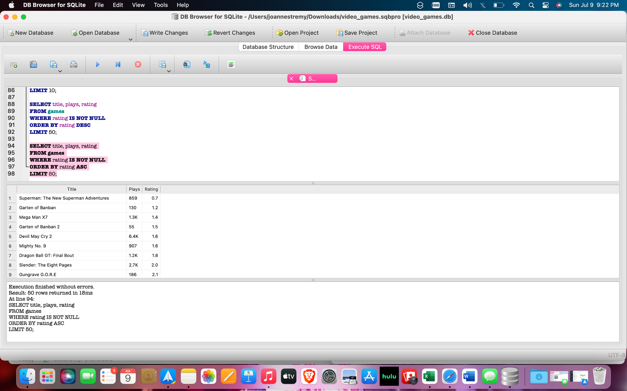

Overall, it seems as if higher rated games have more plays but let’s slice the data in a different way that might make things more clear.

Let’s sort our rankings into these categories so we can see the distribution of plays more clearly and uncover some new trends in our data.

AMAZING

GREAT

GOOD

OKAY

BAD

SELECT title, plays, game_type,

CASE

WHEN rating <= 1 THEN 'Bad'

WHEN rating <= 2 THEN 'Okay'

WHEN rating <= 3 THEN 'Good'

WHEN rating <= 4 THEN 'Great'

WHEN rating <= 5 THEN 'Amazing'

END AS Score

FROM games;

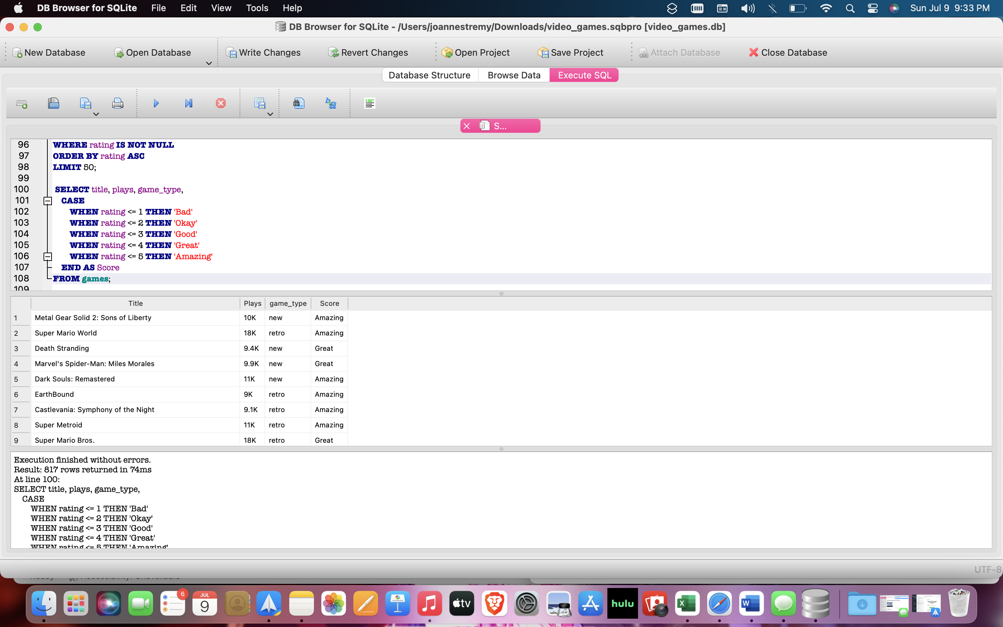

Let’s use these columns to gather some more data:

But let’s add our temporary column first:

ALTER TABLE games

ADD COLUMN score VARCHAR(10);

UPDATE games

SET score =

CASE

WHEN rating <= 1 THEN 'Bad'

WHEN rating <= 2 THEN 'Okay'

WHEN rating <= 3 THEN 'Good'

WHEN rating <= 4 THEN 'Great'

WHEN rating <= 5 THEN 'Amazing'

END;

Let’s see how many games were rated in each score category (great, amazing, good, okay and bad) and how many plays they each received on average.

But first lets clean the data by changing the plays column to a REAL number using the following query:

UPDATE games

SET plays = plays * CASE

WHEN substr(plays, -1) = 'k' THEN CAST(substr(plays, 1, length(plays) - 1) AS REAL) * 1000

ELSE CAST(plays AS REAL)

END;

Here is our new table:

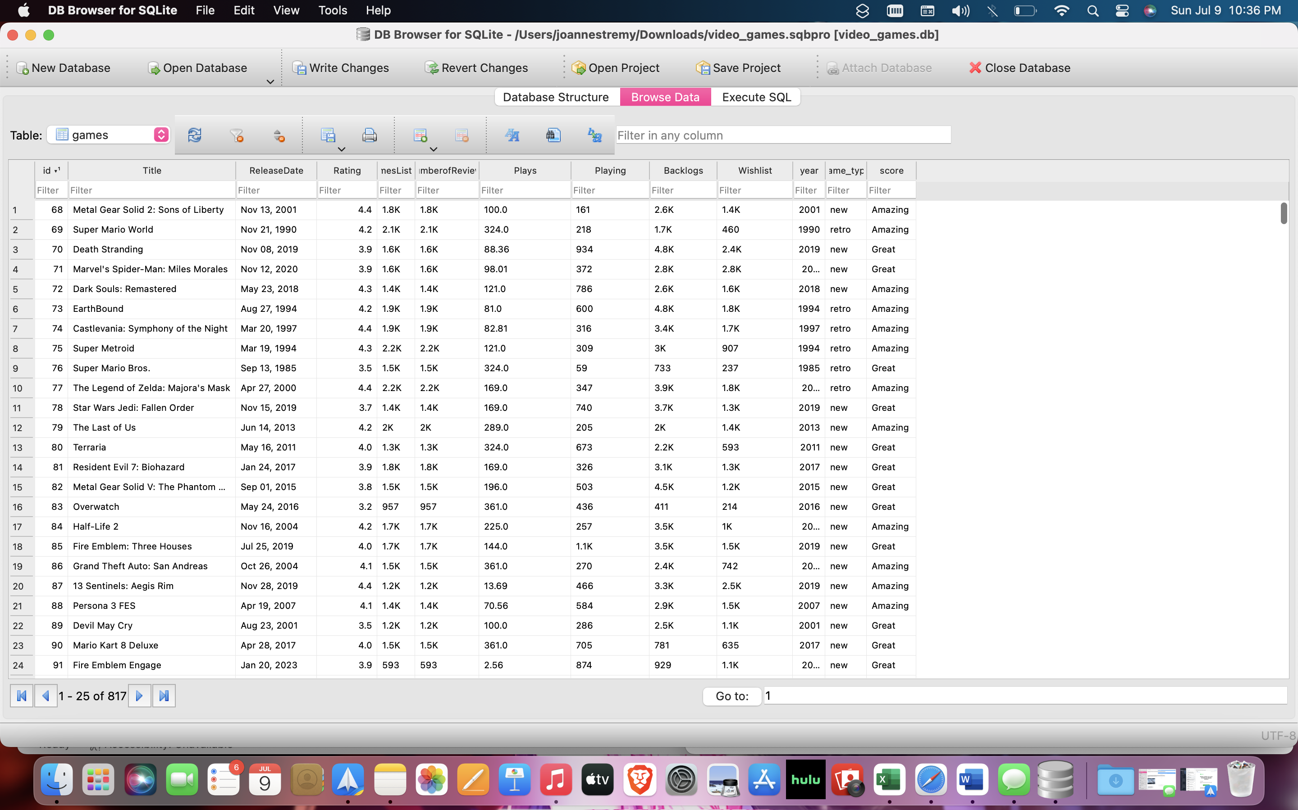

SELECT score, COUNT(score) AS score_count, AVG(plays) AS average_plays

FROM games

WHERE score IS NOT NULL

GROUP BY score

ORDER BY score_count DESC;

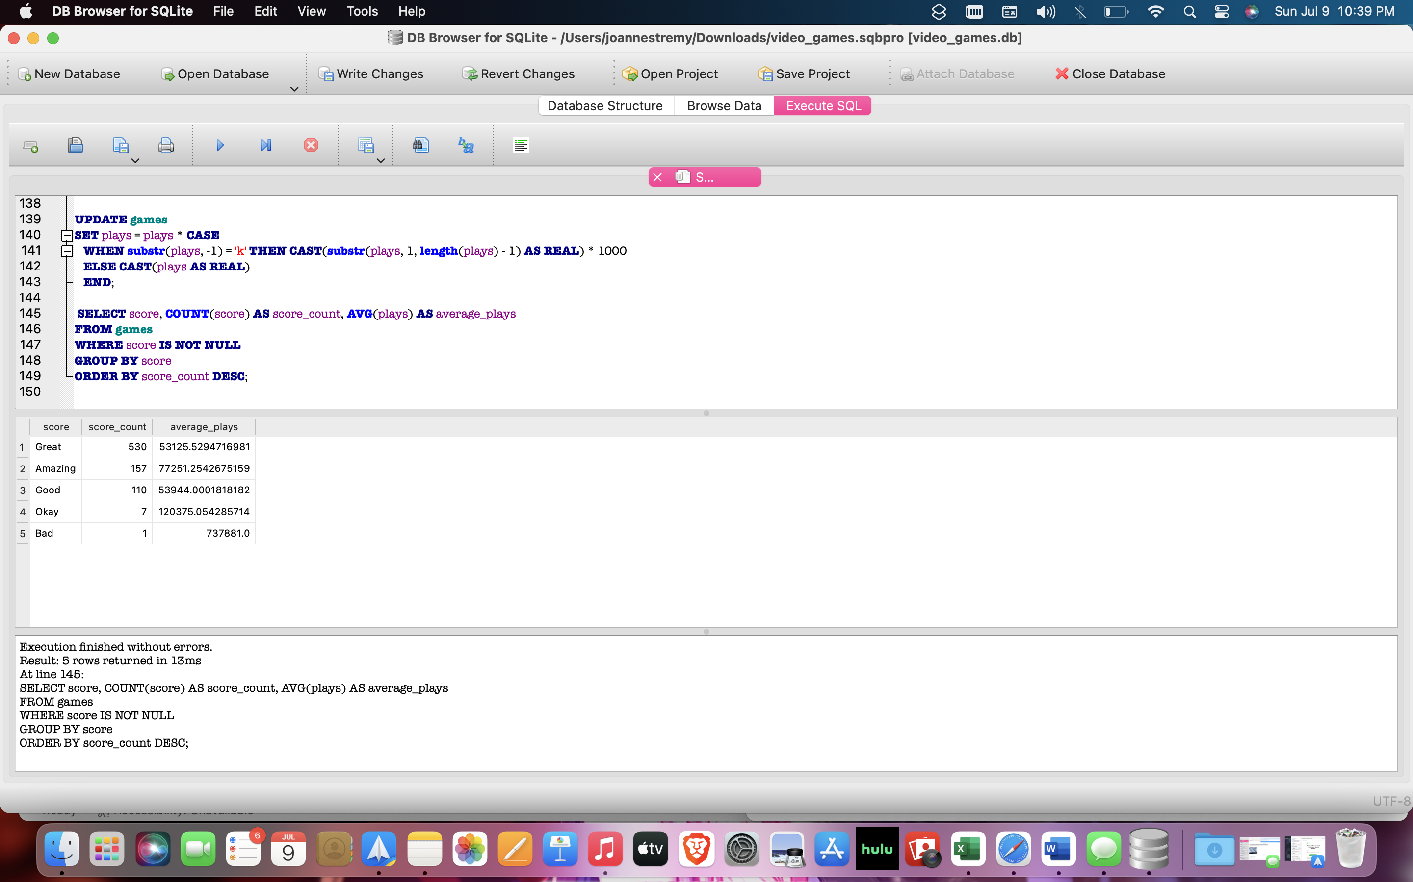

|  |  |  |
| --- | --- | --- |
| Great | 530 | 53125.5294716981 |
| Amazing | 157 | 77251.2542675159 |
| Good | 110 | 53944.0001818182 |
| Okay | 7 | 120375.054285714 |
| Bad | 1 | 737881.0 |

Let’s clean the data in the new column, average_plays to the nearest whole number.

SELECT score, COUNT(score) AS score_count, ROUND(AVG(plays)) AS average_plays

FROM games

WHERE score IS NOT NULL

GROUP BY score

ORDER BY score_count DESC;

|  |  |  |
| --- | --- | --- |
| Great | 530 | 53126.0 |
| Amazing | 157 | 77251.0 |
| Good | 110 | 53944.0 |
| Okay | 7 | 120375.0 |
| Bad | 1 | 737881.0 |

~~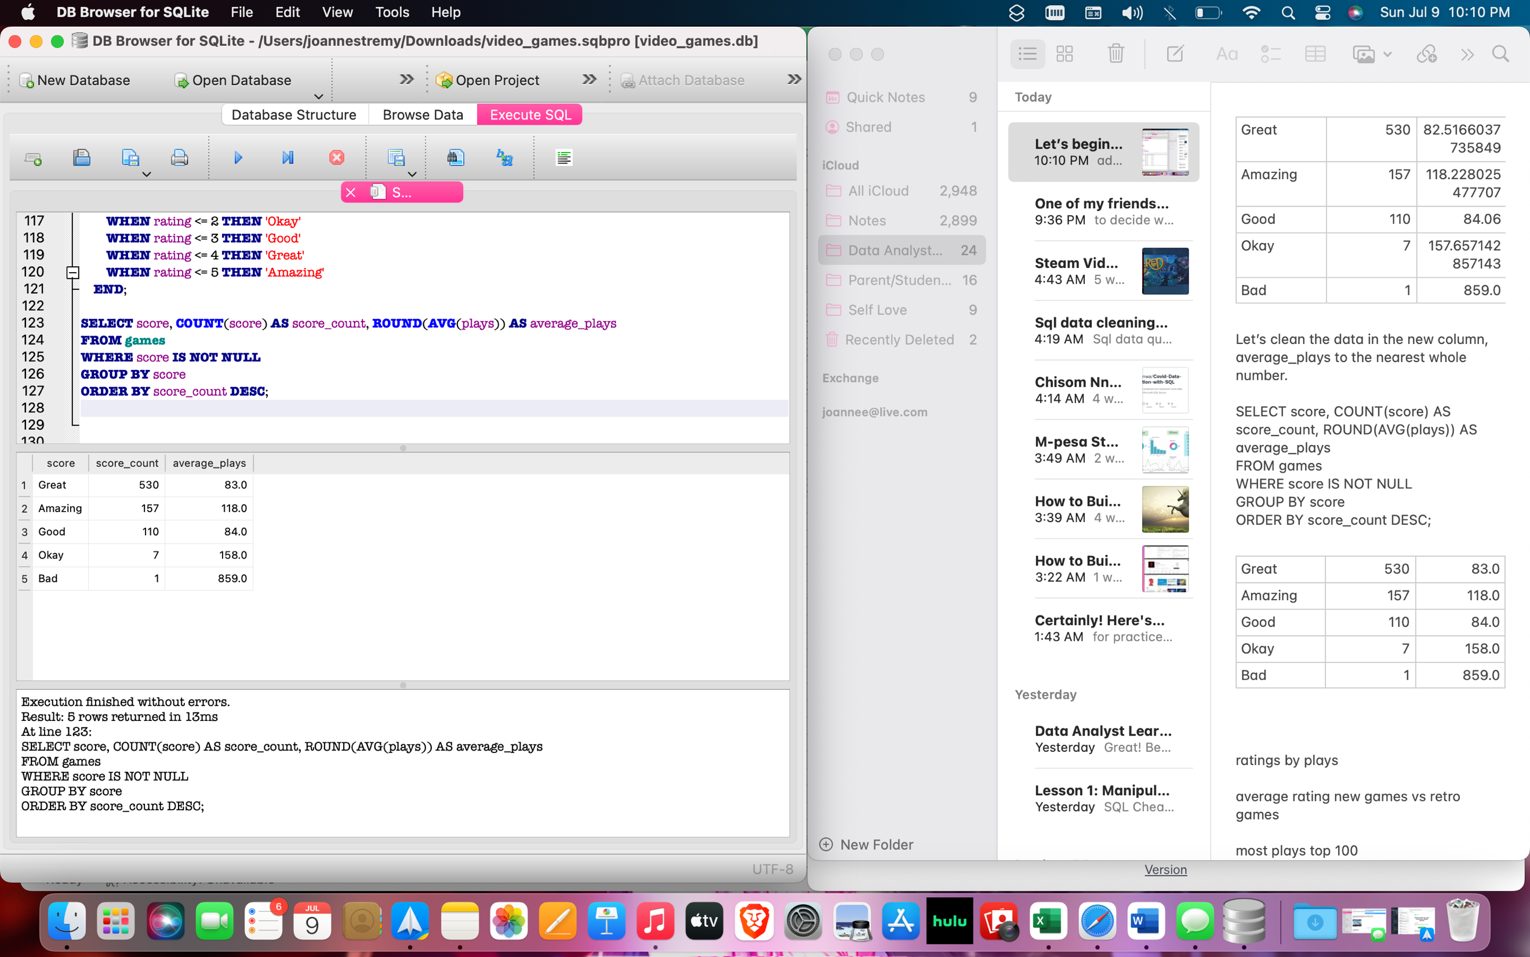~~

There is an outlier in the data as there was only 1 game rated bad and it was

|  |  |  |
| --- | --- | --- |
| Superman: The New Superman Adventures | Bad | 0.7 |

We found it using the following query:

Select title, score, rating

FROM games

WHERE score IS 'Bad';

Let’s excuse this score from our results for now as it is skewing our data and only look at the top three score categories as my friend doesn’t want to play any bad games anyway.

Most games were rated as great with a rating of 3-4, this category averaged 53,126 plays. There were 530 games in this category.

As expected, amazing games averaged the most plays with 77,251. While good games averaged 53944 plays.

Let’s see if retro games had higher average ratings compared to new games.

There wasn’t anything too interesting when we looked at the data separated by retro games vs new games.

There were over 600 more new games compared to retro games, despite this they both averaged around the same number of plays.

Let’s see if higher rated games received a higher number of reviews.

Let’s clean the values in our number of reviews column first.

UPDATE games

SET NumberofReviews = NumberofReviews * CASE

WHEN substr(NumberofReviews, -1) = 'k' THEN CAST(substr(NumberofReviews, 1, length(NumberofReviews) - 1) AS REAL) * 1000

ELSE CAST(NumberofReviews AS REAL)

END;

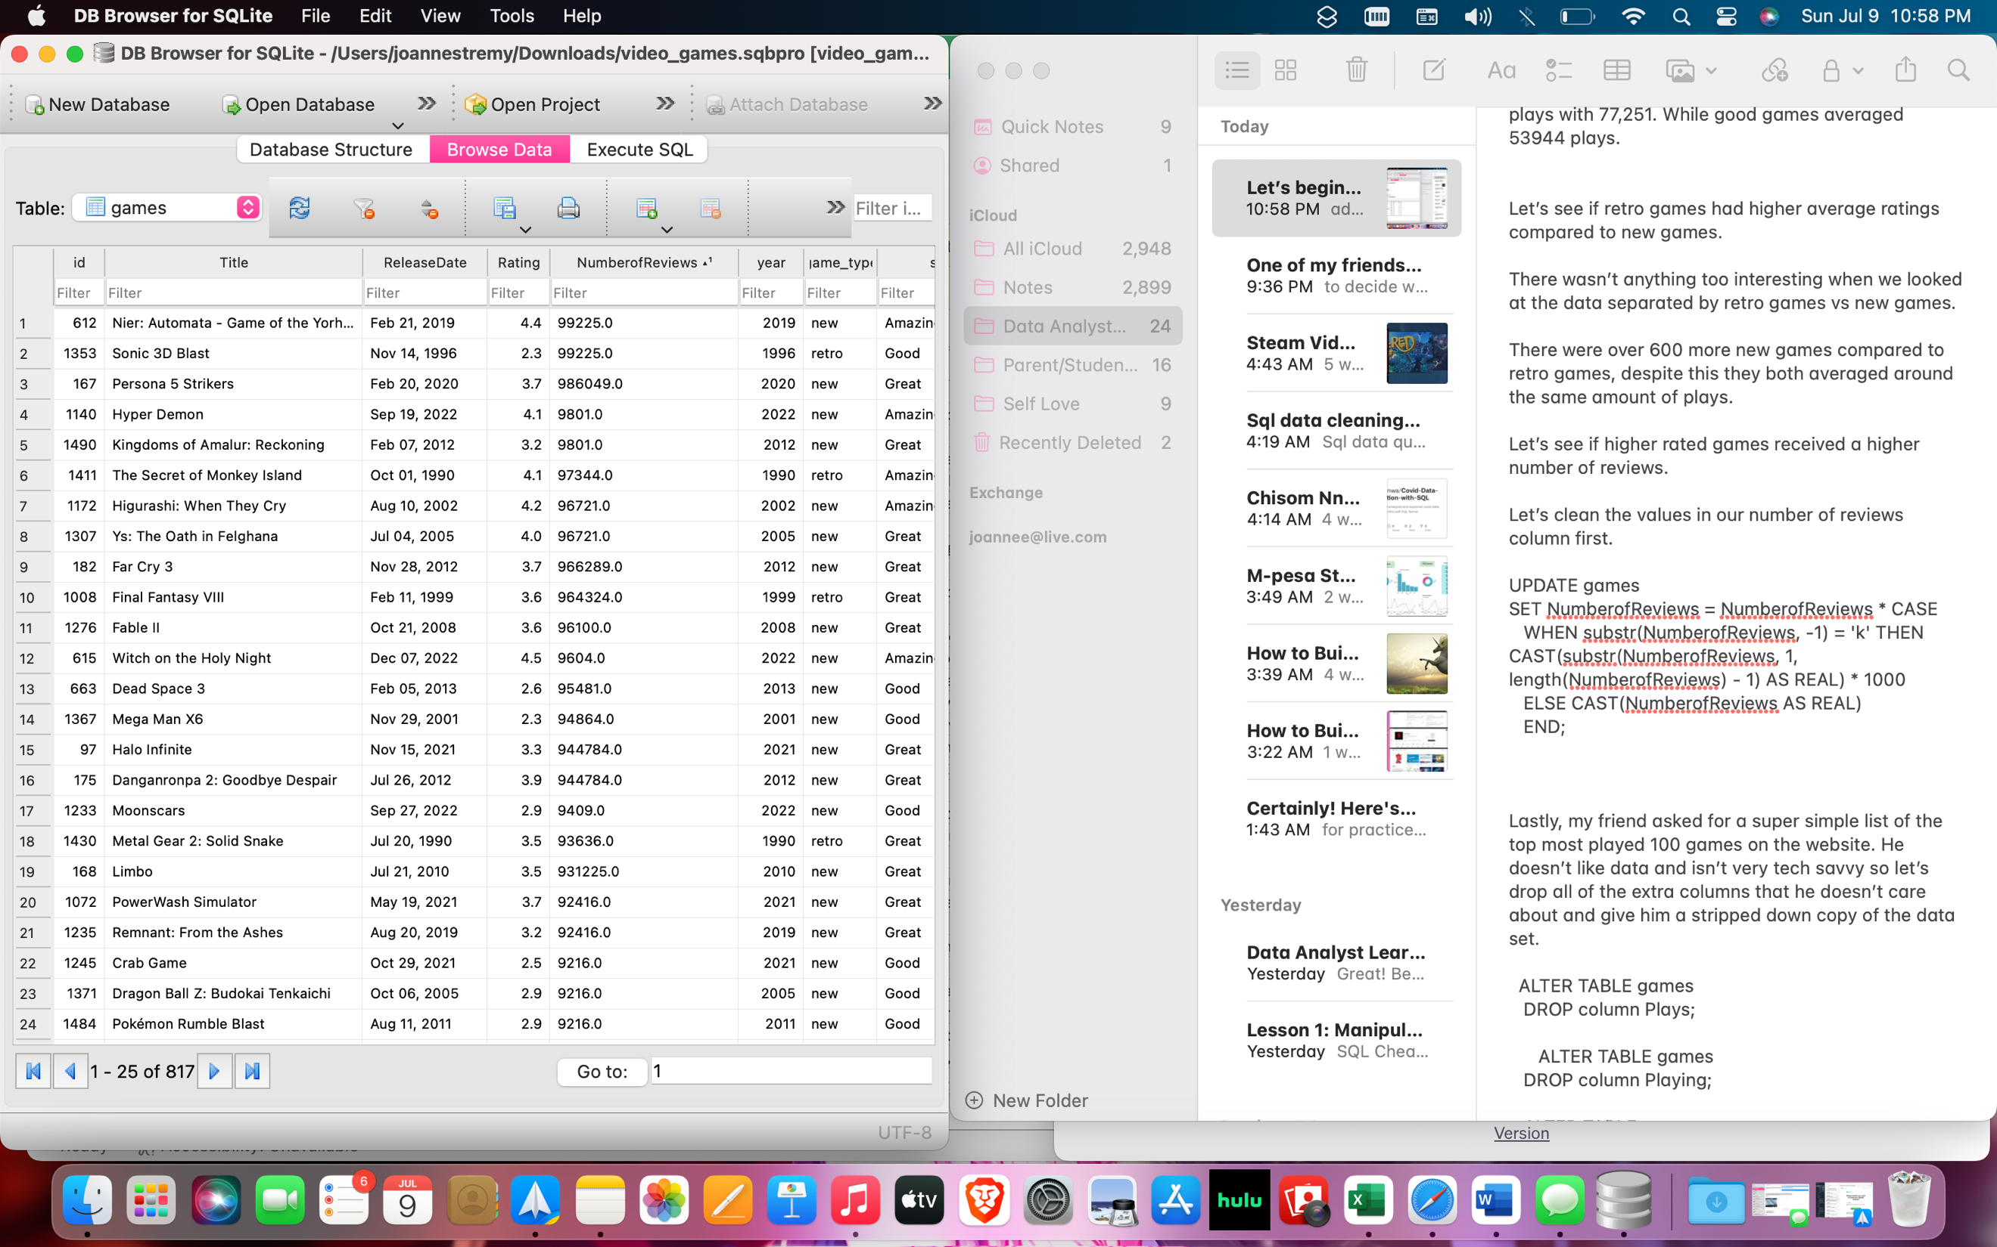

Let’s create a query to see how many reviews each score rating category received:

SELECT score, COUNT(score) AS score_count, ROUND(AVG(NumberofReviews)) AS average_review_count

FROM games

WHERE score IS NOT NULL

GROUP BY score

ORDER BY score_count DESC;

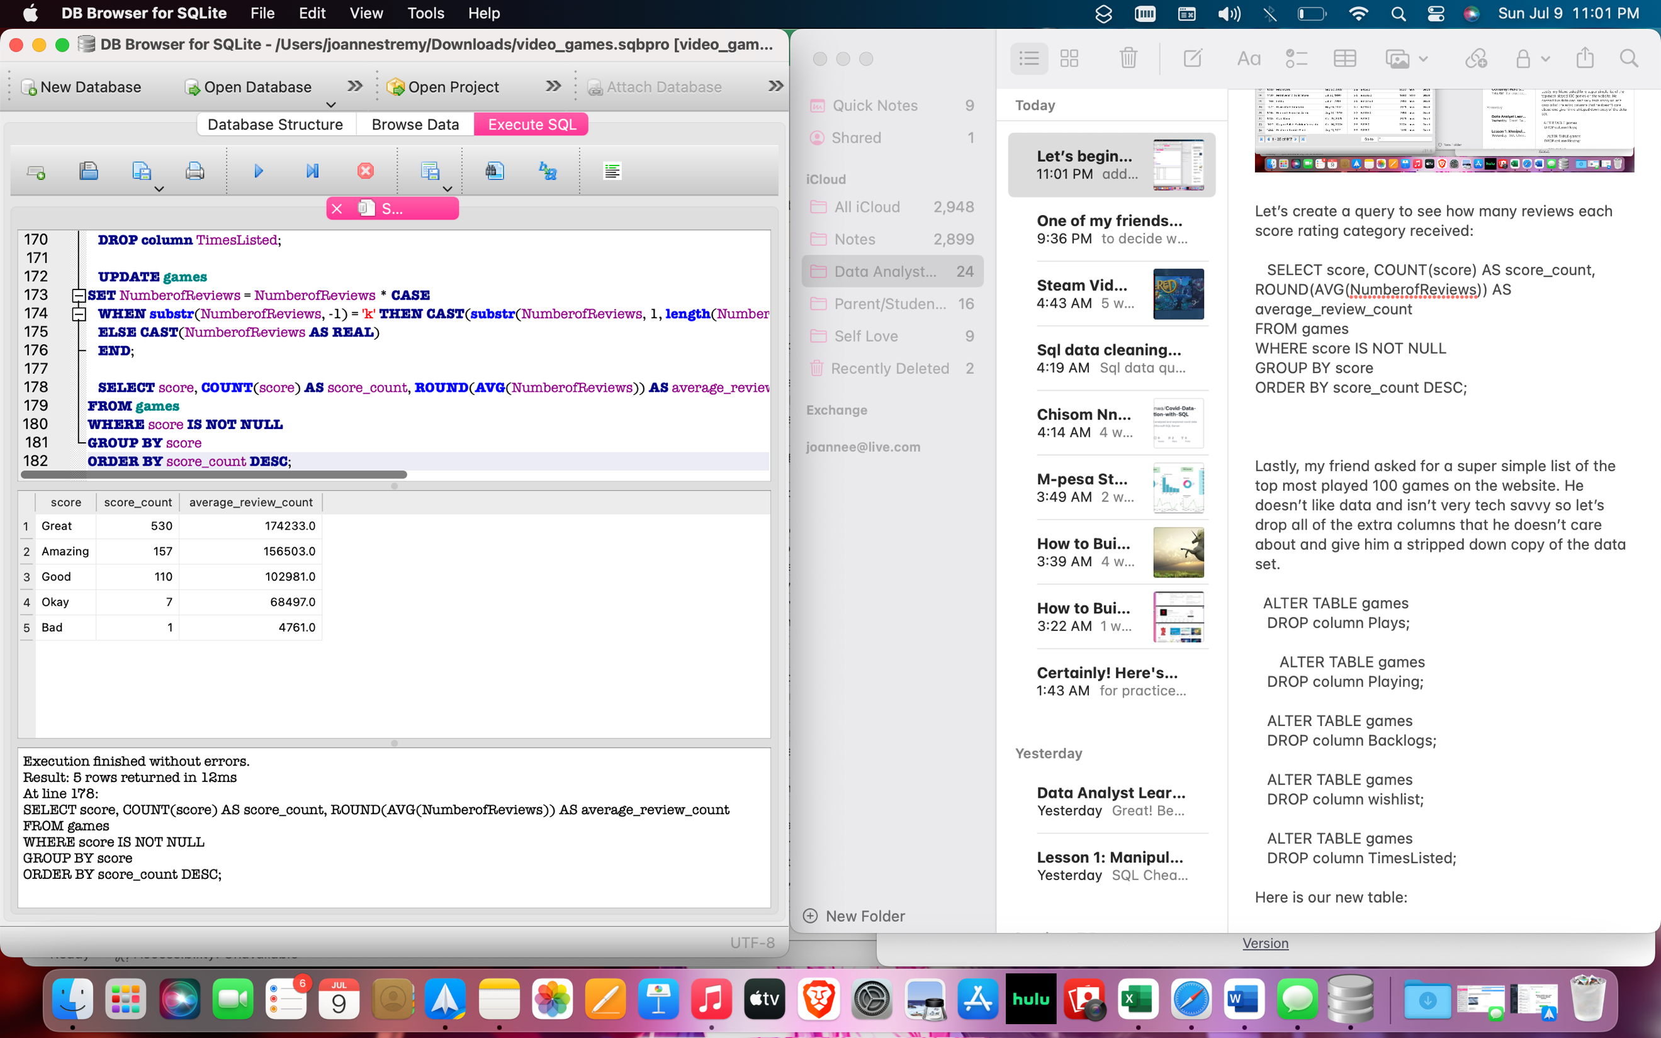

|  |  |  |
| --- | --- | --- |
| Great | 530 | 174233.0 |
| Amazing | 157 | 156503.0 |
| Good | 110 | 102981.0 |
| Okay | 7 | 68497.0 |
| Bad | 1 | 4761.0 |

Nothing surprising here, the score categories with the most games averaged the highest number of reviews. Although it is interesting that the only bad game received nearly 4800 reviews.

Lastly, my friend asked for a super simple list of the top played 100 games on the website. He doesn’t like data and isn’t very tech savvy so let’s drop all of the extra columns that he doesn’t care about and give him a stripped-down copy of the data set.

ALTER TABLE games

DROP column Playing;

ALTER TABLE games

DROP column Backlogs;

ALTER TABLE games

DROP column wishlist;

ALTER TABLE games

DROP column TimesListed;

Here is our new table:

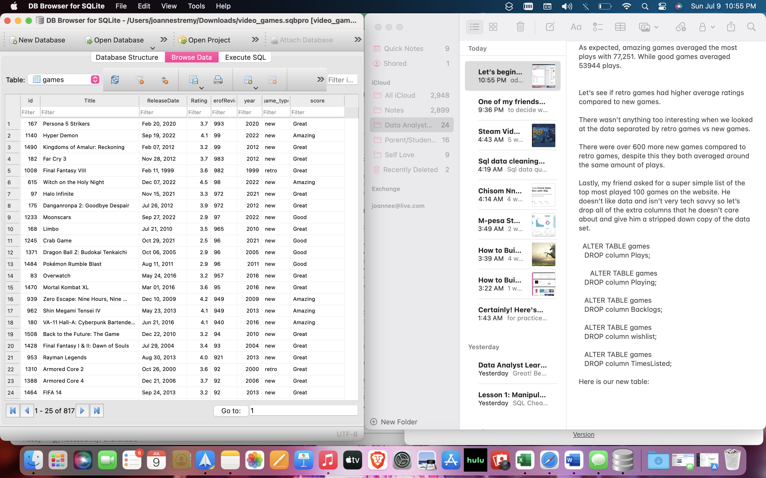

My friend just called and decided that he does want to see the genres in the final table that I send him, let’s use a left join to use our original games table csv to create a temporary table with this data.

SELECT

g.id,

g.title,

go.genres,

FROM games AS g

LEFT JOIN games_original AS go

ON g.id = go.id

ORDER BY g.plays DESC

LIMIT 10;

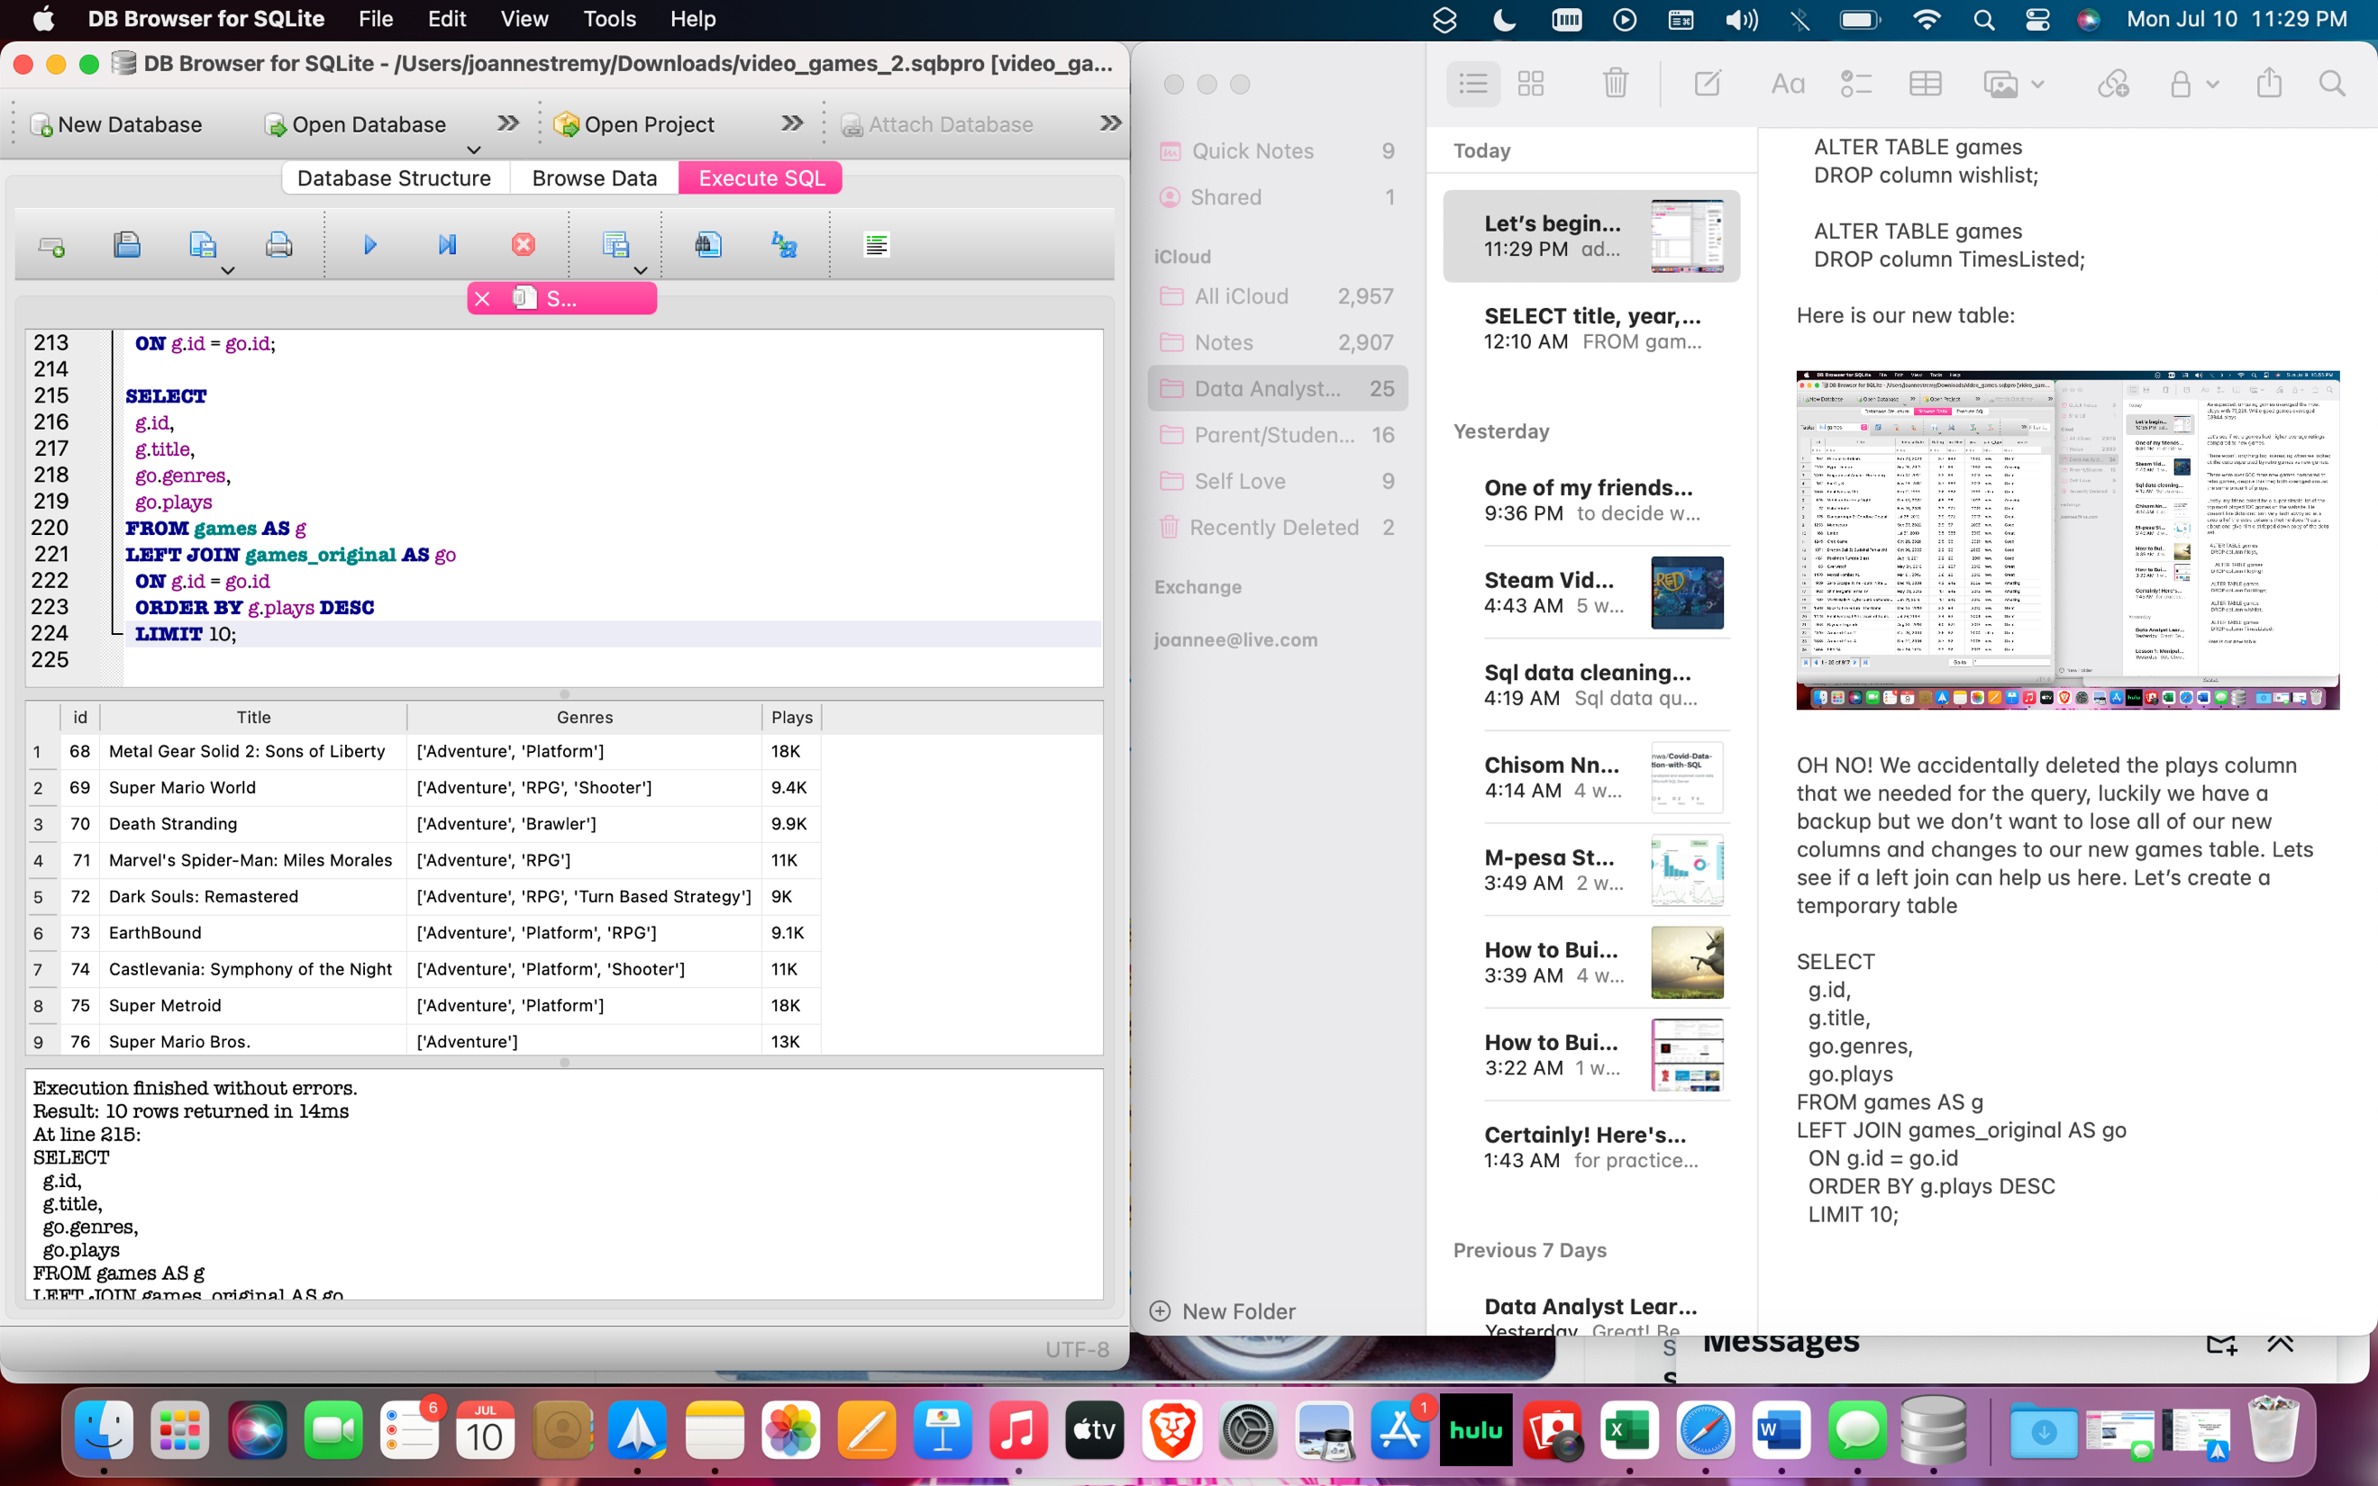

|  |  |  |
| --- | --- | --- |
| 68 | Metal Gear Solid 2: Sons of Liberty | ['Adventure', 'Platform'] |
| 69 | Super Mario World | ['Adventure', 'RPG', 'Shooter'] |
| 70 | Death Stranding | ['Adventure', 'Brawler'] |
| 71 | Marvel's Spider-Man: Miles Morales | ['Adventure', 'RPG'] |
| 72 | Dark Souls: Remastered | ['Adventure', 'RPG', 'Turn Based Strategy'] |
| 73 | EarthBound | ['Adventure', 'Platform', 'RPG'] |
| 74 | Castlevania: Symphony of the Night | ['Adventure', 'Platform', 'Shooter'] |
| 75 | Super Metroid | ['Adventure', 'Platform'] |
| 76 | Super Mario Bros. | ['Adventure'] |
| 77 | The Legend of Zelda: Majora's Mask | ['Adventure'] |

We should be ready to create one last table now that can easily show my friend the top most played games in our data set.

SELECT

g.title, g.plays, g.game_type

FROM games AS g

ORDER BY plays DESC;

|  |  |
| --- | --- |
| Ninja Gaiden Black | 984064.0 |
| Alpha Protocol | 974169.0 |
| Twisted Metal | 972196.0 |
| Chicory: A Colorful Tale | 968256.0 |
| Atomic Heart | 966289.0 |
| Wonderful Everyday: Down the Rabbit-Hole | 964324.0 |
| Mega Man ZX Advent | 952576.0 |
| Indivisible | 938961.0 |
| Nobody Saves the World | 900601.0 |
| Peggle Deluxe | 881721.0 |
| Another World | 881721.0 |
| Jazzpunk | 874225.0 |
| Suikoden | 870489.0 |
| Mario Strikers: Battle League | 868624.0 |
| The Warriors | 859329.0 |
| Mighty No. 9 | 822649.0 |
| Odin Sphere: Leifthrasir | 801025.0 |
| Dragon Quest II: Luminaries of the Legendary Line | 793881.0 |
| Resident Evil 4: Ultimate HD Edition | 790321.0 |
| Ape Escape 3 | 763876.0 |
| World of Horror | 758641.0 |
| Final Fantasy X HD Remaster | 751689.0 |
| Superman: The New Superman Adventures | 737881.0 |
| Fire Emblem: New Mystery of the Emblem | 719104.0 |
| Marvel Snap | 717409.0 |
| Mortal Shell | 717409.0 |
| NBA Jam | 717409.0 |
| Darkwood | 698896.0 |
| Norco | 654481.0 |
| Billy Hatcher and the Giant Egg | 635209.0 |
| JoJo’s Bizarre Adventure: All-Star Battle R | 633616.0 |
| Ib | 619369.0 |
|  |  |

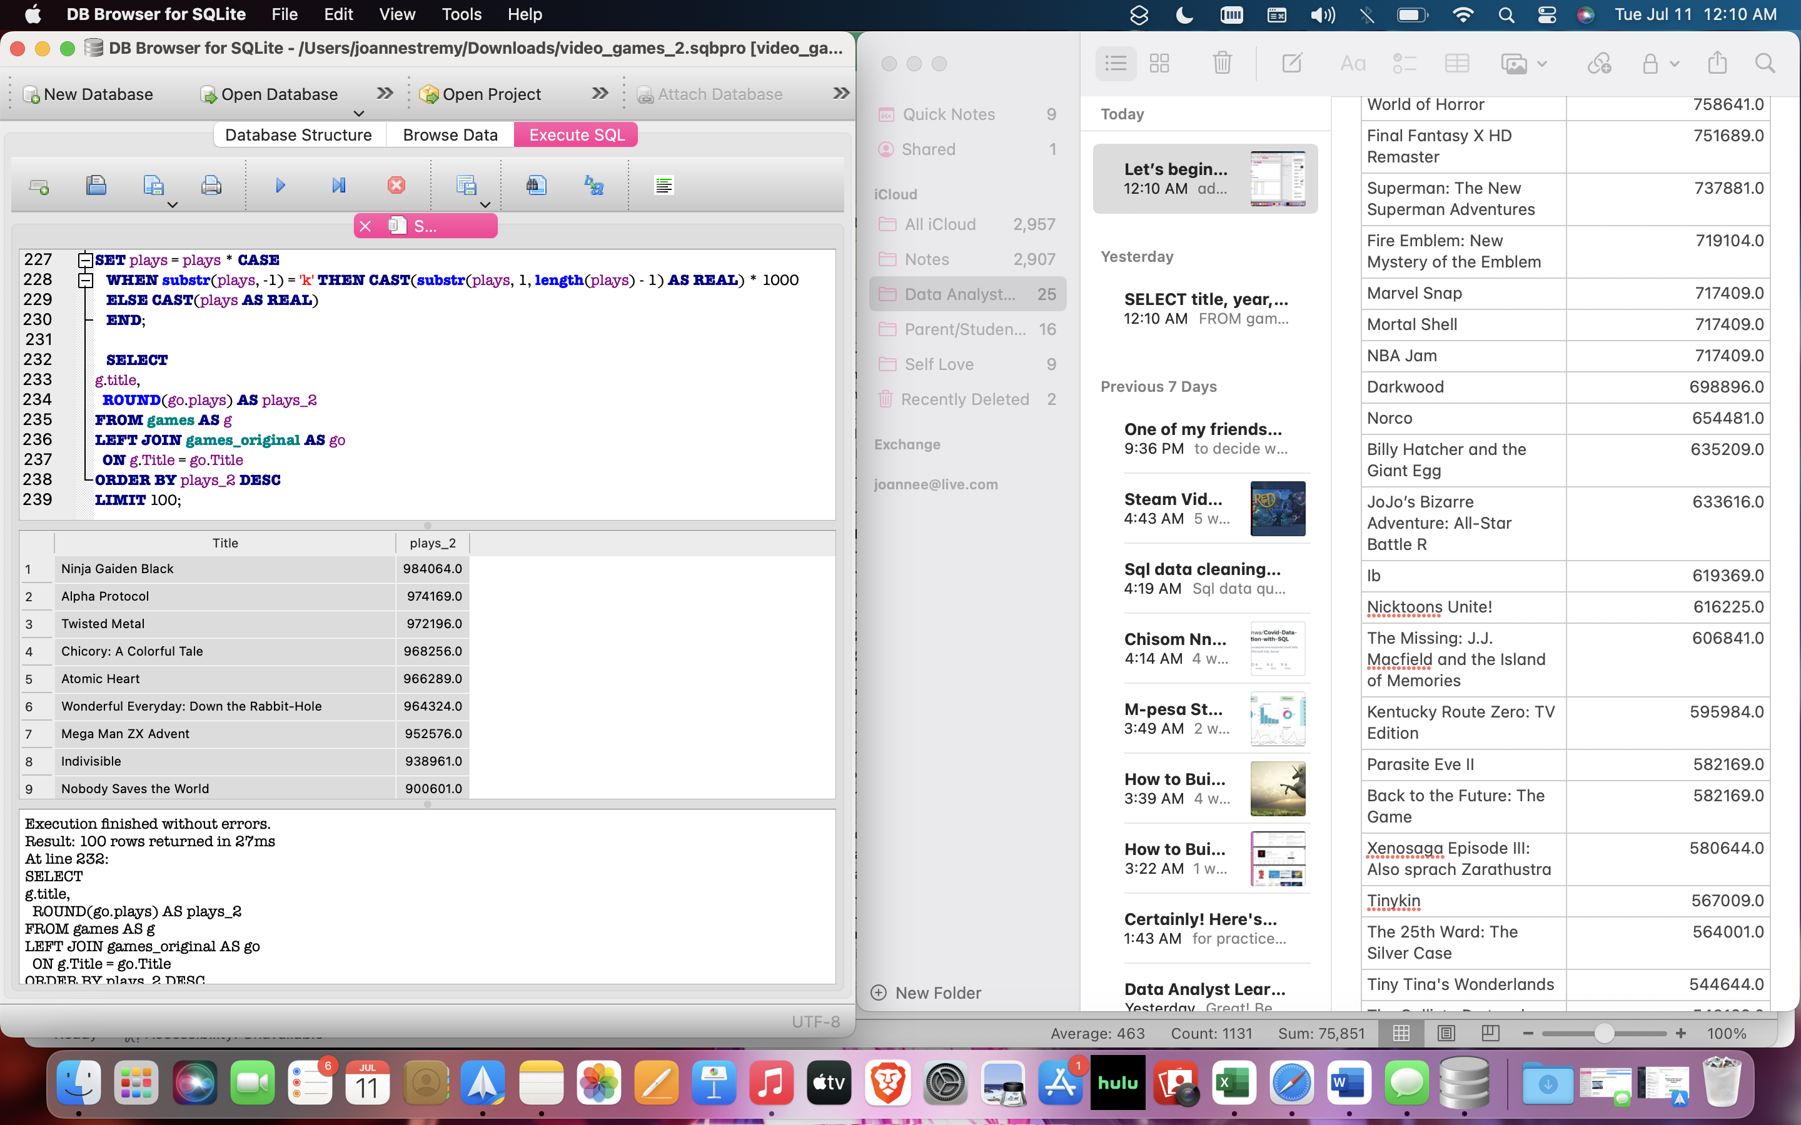

This is exactly what my friend needed. WAIT, he decided he’d rather just stick to the simplest version of the table with just the title, year, game_type, and score (my friend is a difficult cookie). He also wants the data visualized, let’s create a view in SQL to store data for data visualization:

CREATE VIEW games_table_for_friend_project AS

SELECT title, year, rating, game_type, score, plays

FROM games

WHERE Rating IS NOT NULL

ORDER BY Rating DESC;

Let’s save our new games table and start visualizing in our other tools now.